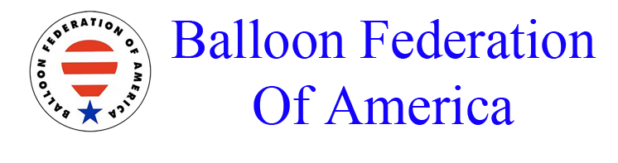


April 25, 2024

2024 US Nationals Rules Changes

- Rule #5.8.1 The text “or if it is decided that the protest is well founded” was removed.
- Rule #6.10.3 was removed. The text read… “After landing, the competitor will detach the logger, turn it off and return it to the Operations Center or other location designated by the Director in briefing.”
- Rule 11.2.3 (Landing at will) 50 meters was added to the rule. The new rule text says: “Unless otherwise stated in the Task Data, a landing at will is not permitted within 50 m of an MMA where a target is displayed, or if no MMA is set, within 200 meters of any goal/target set by the Director or selected by the competitor or any physical mark of the competitor or any physical mark of the competitor (for penalty see distance infringements)”.
- Rule 11.3.4 (Contest Landing) 50 meters was added to the rule. The new rule text says: “Unless otherwise stated in the Task Data, a contest landing is not permitted within 50 m of an MMA or if no MMA is set within 200 meters of any goal/target set by the Director or selected by the competitor. (Rule 13.3.4 distance infringements)”.
- Rule 12.11.2 (Mark) The word “specially” was added to the text. The new text is: “An electronic mark is a track point specially identified for scoring purposes”.
- Rule 12.11.3 This rule is new, it states “if no mark has been achieved the competitor will be scored to their next mark in time or landing position, whichever is best”.
- Rule 12.17.2 (Scoring Period) In the past a competitor would receive a result if their marker (mark) was observed outside the basket at the conclusion of the scoring period. The new rule states: “A competitor will only score if they have a physical marker on the ground, have landed, or have a valid electronic mark within the set time limit”.
- Chapter 15 (Tasks) Reference to “closet valid track point” was removed in several task rules.
  - Please refer to Rule 12.11 (Mark)
- Chapter 15 (Tasks) The word “common” was removed in the following tasks as it related to the
reference point.
  - 15.13 (Minimum Distance)
  - 15.14 (Shortest Flight)
  - 15.16 (Maximum Distance Time)
  - 15.17 (Maximum Distance)

